**ASSIGNMENT I**

**BIT 302**

**Software Engineering**



**Project Proposal**

**Covid Testing Information System (CTIS)**

**Prepared by:**

Team Leader: Pande Putu Rama Pratama Putra (E1700877)

I Nengah Wahyudi Setiawan (E1700868)

Contact Details:

[ramapratama657@gmail.com](mailto:ramapratama657@gmail.com)

nengahwahyudi90[@gmail.com](mailto:sidi.meisanjaya2013@gmail.com)

2021/2022

Table of Contents

Functional requirements 3

Non – Functional Requirements 3

Use Case Diagram 4

Analysis Class Diagram 6

Expanded Use Case 6

Task Division 12

System Sequence Diagram 13

Contracts 21

Functional requirements

In the website there will be several menus:

* Register Test Center

This menu can be access by Test Centre Manager. It allows Test Centre Manager to register Test Centre’s name.

* Record Tester

This menu can be access by Test Centre Manager. It allows Test Centre Manager to set and record the centre officer position as “Tester”.

* Manage Test Kit Stock

This menu can be access by Test Centre Manager. It allows Test Centre Manager to manage the stock of test kits.

* Generate Test Report

This menu can be access by Test Centre Officer. It allows Test Centre Officer to display the history of all tests report.

* Record New Test

This menu can be access by Tester. It allows Tester to record the patient that have taken a test.

* Update Test Result

This menu can be access by Tester. It allows Tester to update the results of a test from the patient and patient can view the result.

* View Testing History

This menu can be access by Patent. It allows Patient to view all history of tests that have been taken.

Non – Functional Requirements

* Provide accurate information

Accurate, precise, and mus be appropriate that the data entered by the admin

* Easy to use

The system must have simple and easy-to-use interface, so the user will be easier to use

* Modifiability

Administrator can edit all the data like testID, status, etc. Only user can view their status

Use Case Diagram

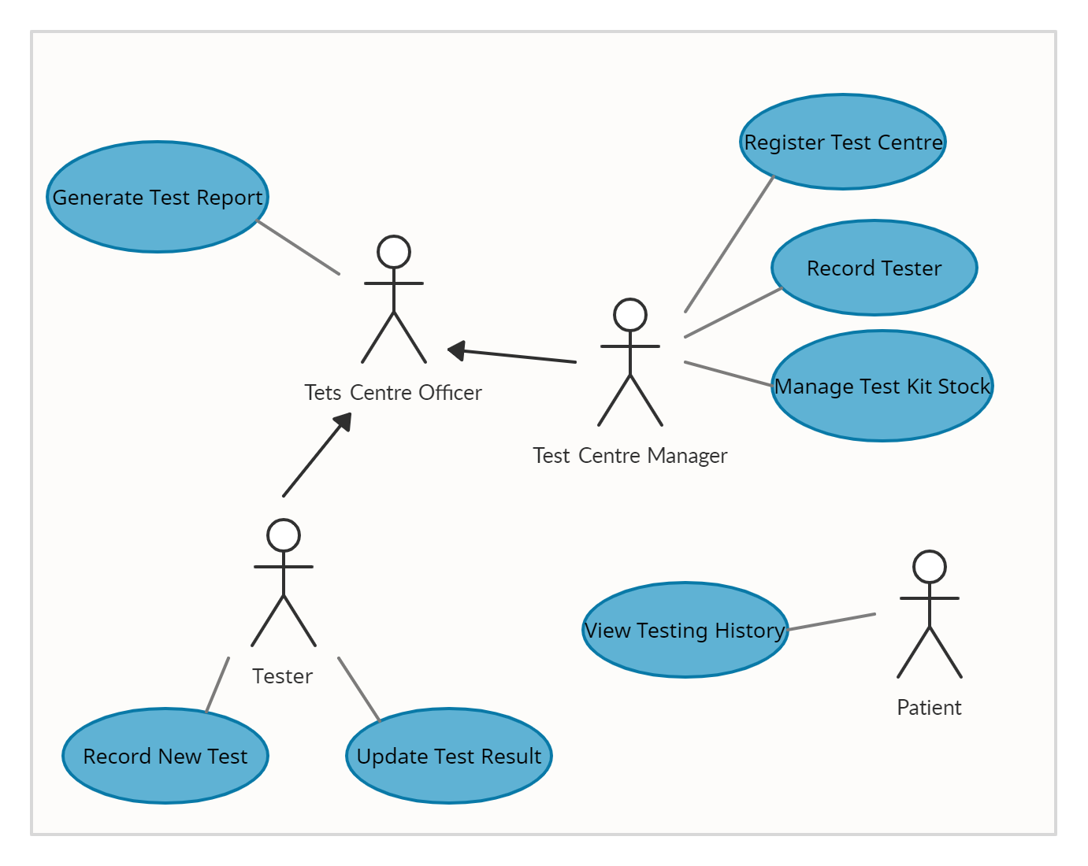

Use Cases

|  |  |  |
| --- | --- | --- |
| Use Case | Actor | Requirement |
| Register Test Centre | Test Centre Manager | Page for Test Centre Manager in register the Test Centre. |
| Record Tester | Test Centre Manager | Page for Test Centre Manager in record a new Test Centre Officer with position “Tester”. |
| Manage Test Kit Stock | Test Centre Manager | Page for Test Centre Manager to manage the stock of test kits. |
| Generate Test Report | Test Centre Officer | Page for Test Centre Officer to display history all test that have been administered the officer. |
| Record New Test | Tester | Page for Tester to record a patient that has taken a test. |
| Update Test Result | Tester | Page for Tester to update the test result from patient. |
| View Testing History | Patient | Page for Patient to view all history of test that have been taken. |

Analysis Class Diagram

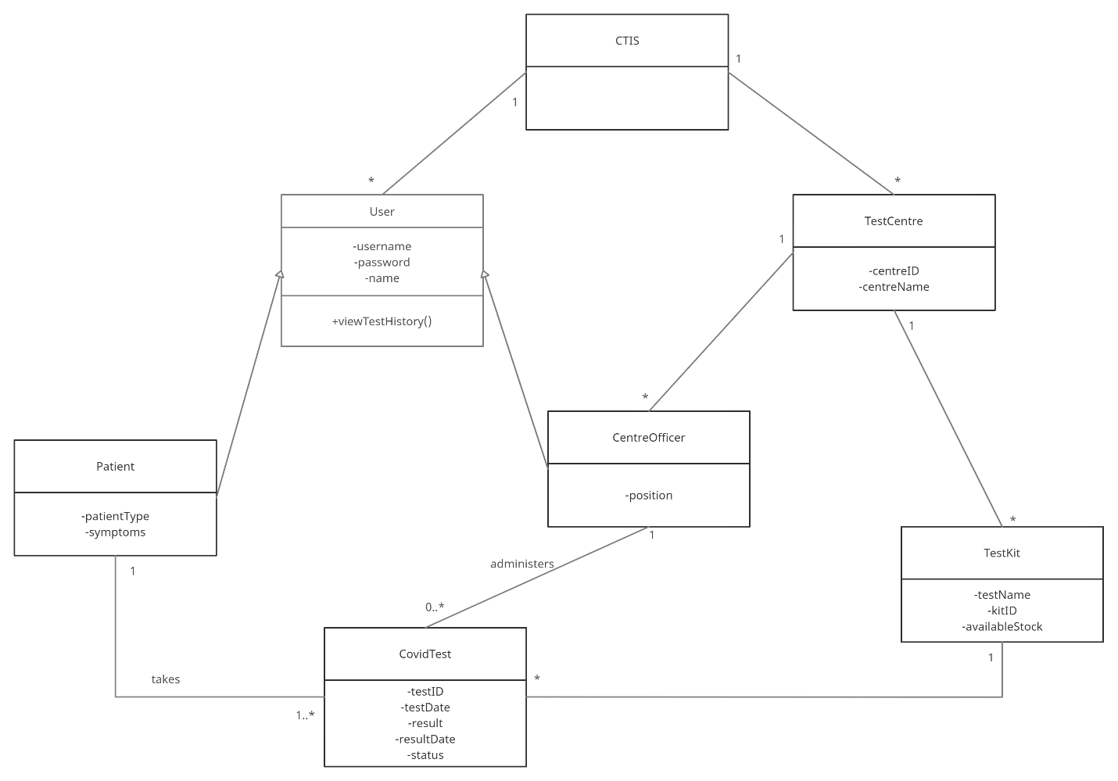

Expanded Use Case

|  |  |
| --- | --- |
| **Use Case 1** | Register Test Centre |
| **Goal in Context** | To allow Test Centre Manager register Test Centre’s name |
| **Primary Actor**  **Secondary Actor** | Test Centre Manager |
| **Trigger** | Test Centre has been approved and Test Centre Manager’s account has been set up as a centre officer |
| **Typical Course of Events Actor Action** | **System Response** |
| 1. This use case starts when the Test Centre Manager wants to register the centre’s name. |  |
| 1. The Test Manager logs in to register the centre’s name. | Test centre’s name is registered. The centreID is created automatically and recorded. |
| **Alternative Course of Events** | |

|  |  |
| --- | --- |
| **Use Case 2** | Record Tester |
| **Goal in Context** | To allow Test Centre Manager set and record the centre officer position as “Tester” |
| **Primary Actor**  **Secondary Actor** | Test Centre Manager |
| **Trigger** | The Test Centre Manager wants to record a new Test Centre Officer with the position ‘tester’. |
| **Typical Course of Events Actor Action** | **System Response** |
| 1. This use case starts when the Test Centre Manager wants to record a new Test Centre Officer’s position with “Tester”. |  |
| 1. The Test Manager logs in to records the username, password, and name of the officer and set the position to “Tester”. | The Test Centre Officer that have been recorded is set as “Tester”. |
| **Alternative Course of Events**  **Line 2:** If there another record new Centre Officer to set the position is “Tester”, repeat line 2. | |

|  |  |
| --- | --- |
| **Use Case 3** | Manage Test Kit Stock |
| **Goal in Context** | To allow Test Centre Manager able to manage the stock of test kits |
| **Primary Actor**  **Secondary Actor** | Test Centre Manager |
| **Trigger** | The Test Centre Manager receives new stock of test kits |
| **Typical Course of Events Actor Action** | **System Response** |
| 1. This use case starts when the Test Centre Manager wants to manage the stock of test kits |  |
| 1. The Test Manager logs in to records the test kit name and stock | The Test Kit name and stock is recorded and kitID is generated |
| **Alternative Course of Events**  **Line 2:** If there is existing stock for a given kitID, the stock of the Test Kit is updated | |

|  |  |
| --- | --- |
| **Use Case 4** | Generate Test Report |
| **Goal in Context** | To allow Test Centre Officer able to display the history all tests report |
| **Primary Actor**  **Secondary Actor** | Test Centre Officer |
| **Trigger** | The Test Centre Officer wants to view a test report |
| **Typical Course of Events Actor Action** | **System Response** |
| 1. This use case starts when the Test Centre Officer wants to view a test report |  |
| 1. The Test Officer logs in with a username and password | The Test Officer successfully logs in and display all history of test report that have been administered |
| **Alternative Course of Events**  **Line 2:** If the username and password of Test Centre Officer is incorrect, system will display alert about incorrect | |

|  |  |
| --- | --- |
| **Use Case 5** | Record New Test |
| **Goal in Context** | To allow Tester record the patient |
| **Primary Actor**  **Secondary Actor** | Tester |
| **Trigger** | The Tester wants to record a patient that has been taken a test |
| **Typical Course of Events Actor Action** | **System Response** |
| 1. This use case starts when the Tester wants to record a patients |  |
| 1. The Tester logs in with a username and password | The Tester successfully logs in |
| 1. The Tester records username, password, name, patient type, and symptoms for the patient | Successfully records data for the patient. The date of the test and the testID is automaticaly generated. The status of the test is “Pending” |
| **Alternative Course of Events**  **Line 2:** If the Test Centre Officer’s position is not “Tester”, system will display alert incorrect username and password, and tesrerthe officer can not record the data of the patient.  **Line 3a:** If the Patient has taken a test before, the Tester updates the patient type and symptoms only. The date of the test and the testID is automaticaly generated. The status of the test is “Pending”  **Line 3b:** If the Tester is not fulfill the data of the patient, the system will not successfully record data of the patient**.** | |

|  |  |
| --- | --- |
| **Use Case 6** | Update Test Result |
| **Goal in Context** | To allow Tester update the results of a test from the patient and patient can view the result |
| **Primary Actor**  **Secondary Actor** | Tester |
| **Trigger** | The result of the test is received and The Tester want to update the results of the test |
| **Typical Course of Events Actor Action** | **System Response** |
| 1. This use case starts when The Tester want to update the results of a test |  |
| 1. The Tester logs in with a username and password | The Tester successfully logs in |
| 1. The Tester enters the testID | Successfully retreive the test details |
| 1. The Tester enters the results and result date | Successfully record the results and the result date. The status of the test is “Complete” |
| **Alternative Course of Events**  **Line 3:** If the Tester input wrong testID, it will not display the Patient’s data and can not update the results of the test.  **Line 4:** If the Tester is not fulfill the results and result date, the system will not successfully record data of the patient**.** | |

|  |  |
| --- | --- |
| **Use Case 7** | View Testing History |
| **Goal in Context** | To allow Patient view all history of tests that have been taken |
| **Primary Actor**  **Secondary Actor** | Patient |
| **Trigger** | The patient want to view the results of the tests |
| **Typical Course of Events Actor Action** | **System Response** |
| 1. This use case starts when The Patient want to view the results of the tests |  |
| 1. The Patient logs in with a username and password | Patient successfully logs in and display all the history of the tests |
| **Alternative Course of Events**  **Line 2:** If the Patient input wrong username and password, it will not display the history of all the tests. | |

|  |  |
| --- | --- |
| **Use Case 8** | Login |
| **Goal in Context** | To allow user to login as their status positions |
| **Primary Actor**  **Secondary Actor** | All user |
| **Trigger** | User wants to logs in to website |
| **Typical Course of Events Actor Action** | **System Response** |
| 1. This use case starts when user wants to logs in |  |
| 1. User logs in with a username and password | User successfully logs in and display page as their status positions |
| **Alternative Course of Events**  **Line 2:** If the user input wrong username and password, it will not display the page as their status positions | |

Task Division

|  |  |
| --- | --- |
| **Required Behaviour** | **Member’s Name** |
| Register Test Centre | Wahyudi |
| Record Tester | Wahyud |
| Manage Test Kit Stock | Wahyudi |
| Generate Test Report | Rama |
| Record New Test | Rama |
| Update Test Result | Rama |
| View Testing History | Rama |
| Login | Rama |

System Sequence Diagram

1. Register Test Centre

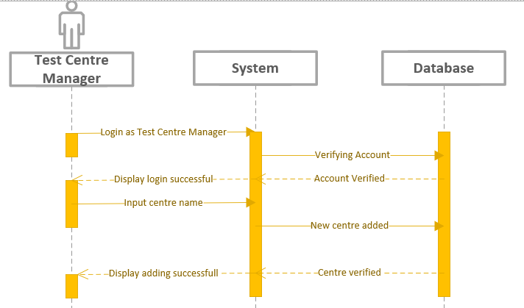

|  |  |
| --- | --- |
| **Cross References** | **Register Test Centre** |
| **Operation** | Login |
| **Responsible** | To get access to page of test centre manager |
| **Pre-conditions** | * The username of user must be available * The password of user must be available |
| **Post-conditions** | * Username are matched according to names in database * Password are matched based on user’s password in database |

|  |  |
| --- | --- |
| **Cross References** | **Register Test Centre** |
| **Operation** | Input Centre Name |
| **Responsible** | To Register Test Centre |
| **Pre-conditions** | * Name of the Test Centre must be available |
| **Post-conditions** | * Test Centre’s name are successfully registered |

2. Record Tester

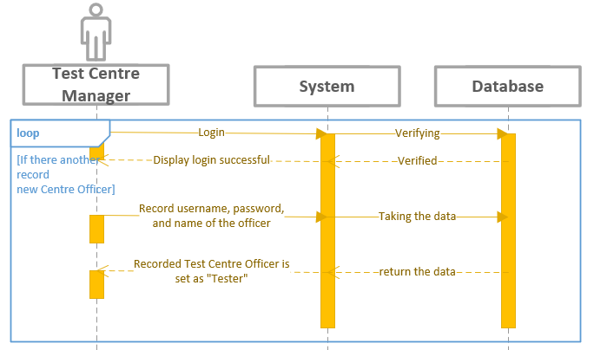

|  |  |
| --- | --- |
| **Cross References** | **Record Tester** |
| **Operation** | Login |
| **Responsible** | To get access page of test centre manager |
| **Pre-conditions** | * The username of user must be available * The password of user must be available |
| **Post-conditions** | * Username are matched according to names in database * Password are matched based on user’s password in database |

|  |  |
| --- | --- |
| **Cross References** | **Record Tester** |
| **Operation** | Set and record the centre officer position as “Tester” |
| **Responsible** | To set the centre officer’s position to “Tester” |
| **Pre-conditions** | * The username of centre officer must be matched in database * The password of centre officer must be matched in database * The name of centre officer must be matched in database |
| **Post-conditions** | * Username are matched according to names in database * Password are matched based on user’s password in database * Name are matched based on user’s name in database * Positions status of the centre officer changed to “Tester” |

3. Manage Test Kit Stock

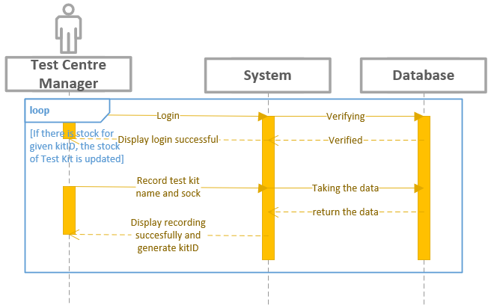

|  |  |
| --- | --- |
| **Cross References** | **Manage Test Kit Stock** |
| **Operation** | Login |
| **Responsible** | To get access page of test centre manager |
| **Pre-conditions** | * The username of usermust be available * The password of user must be available |
| **Post-conditions** | * Username are matched according to names in database * Password are matched based on user’s password in database |

|  |  |
| --- | --- |
| **Cross References** | **Manage Test Kit Stock** |
| **Operation** | Record test kit |
| **Responsible** | To update test kit name and stock |
| **Pre-conditions** | * The name of test kit must available to record * The stock must know many available to record |
| **Post-conditions** | * Name of the test kit and stock are recorded and generate kitID |

4. Generate Test Report

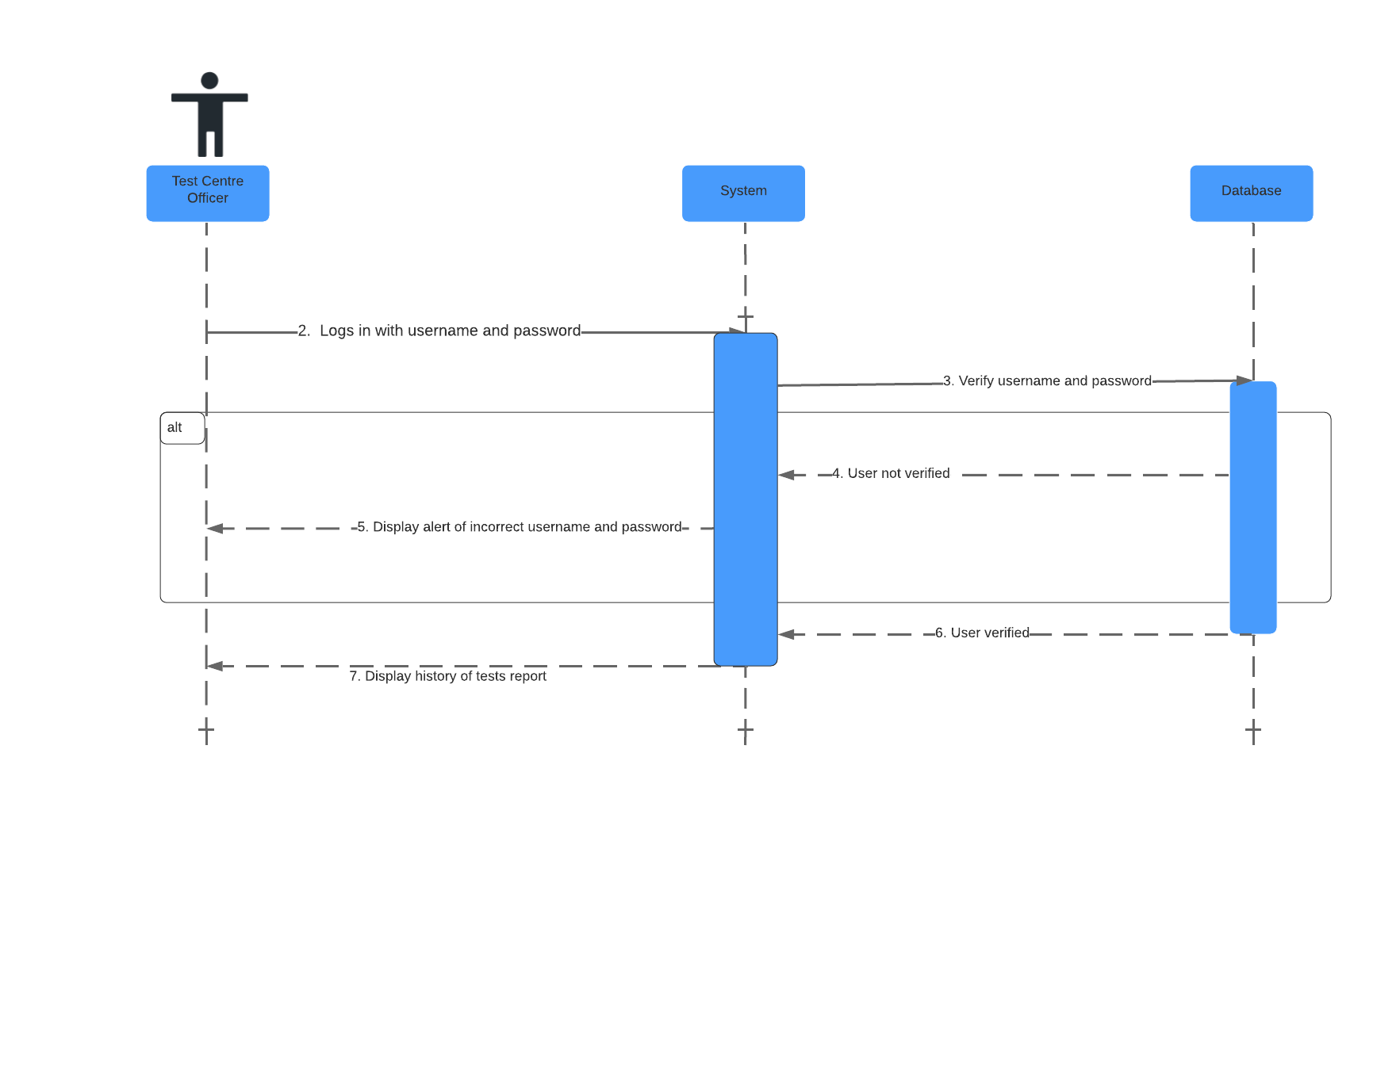

|  |  |
| --- | --- |
| **Cross References** | **Generate Test Report** |
| **Operation** | Login username and password |
| **Responsible** | To get access page of test centre officer |
| **Pre-conditions** | * The username of user must be available * The password of user must be available |
| **Post-conditions** | * Username are matched according to names in database * Password are matched based on user’s password in database |

|  |  |
| --- | --- |
| **Cross References** | **Generate Test Report** |
| **Operation** | Display all history report |
| **Responsible** | To view all history of the report |
| **Pre-conditions** | * The report object must be available |
| **Post-conditions** | * All the report that administered is shown |

5. Record New Test

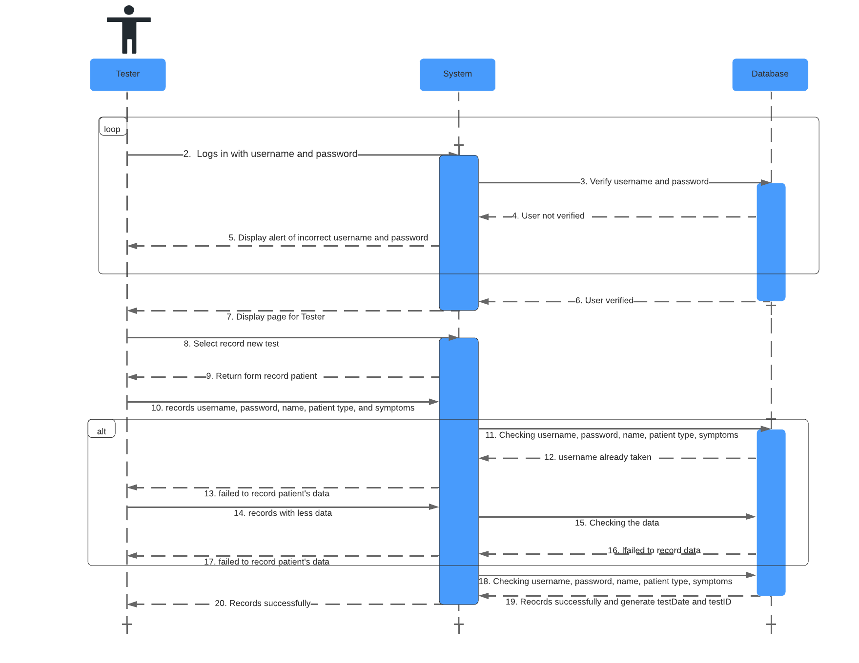

|  |  |
| --- | --- |
| **Cross References** | **Record New Test** |
| **Operation** | Login username and password |
| **Responsible** | To get access page of tester |
| **Pre-conditions** | * The username of user must be available * The password of user must be available |
| **Post-conditions** | * Username are matched according to names in database * Password are matched based on user’s password in database |

|  |  |
| --- | --- |
| **Cross References** | **Record New Test** |
| **Operation** | Select record new test |
| **Responsible** | To get form of new test |
| **Pre-conditions** | * The form object must be available |
| **Post-conditions** | * Succesfully displayed form of new test |

|  |  |
| --- | --- |
| **Cross References** | **Record New Test** |
| **Operation** | Records username, password, name, patient type, and symptoms |
| **Responsible** | To record data of the patient |
| **Pre-conditions** | * The data object must be available |
| **Post-conditions** | * Succesfully record data of the patients * Successfully generate date of test and testID |

6. Update Test Results

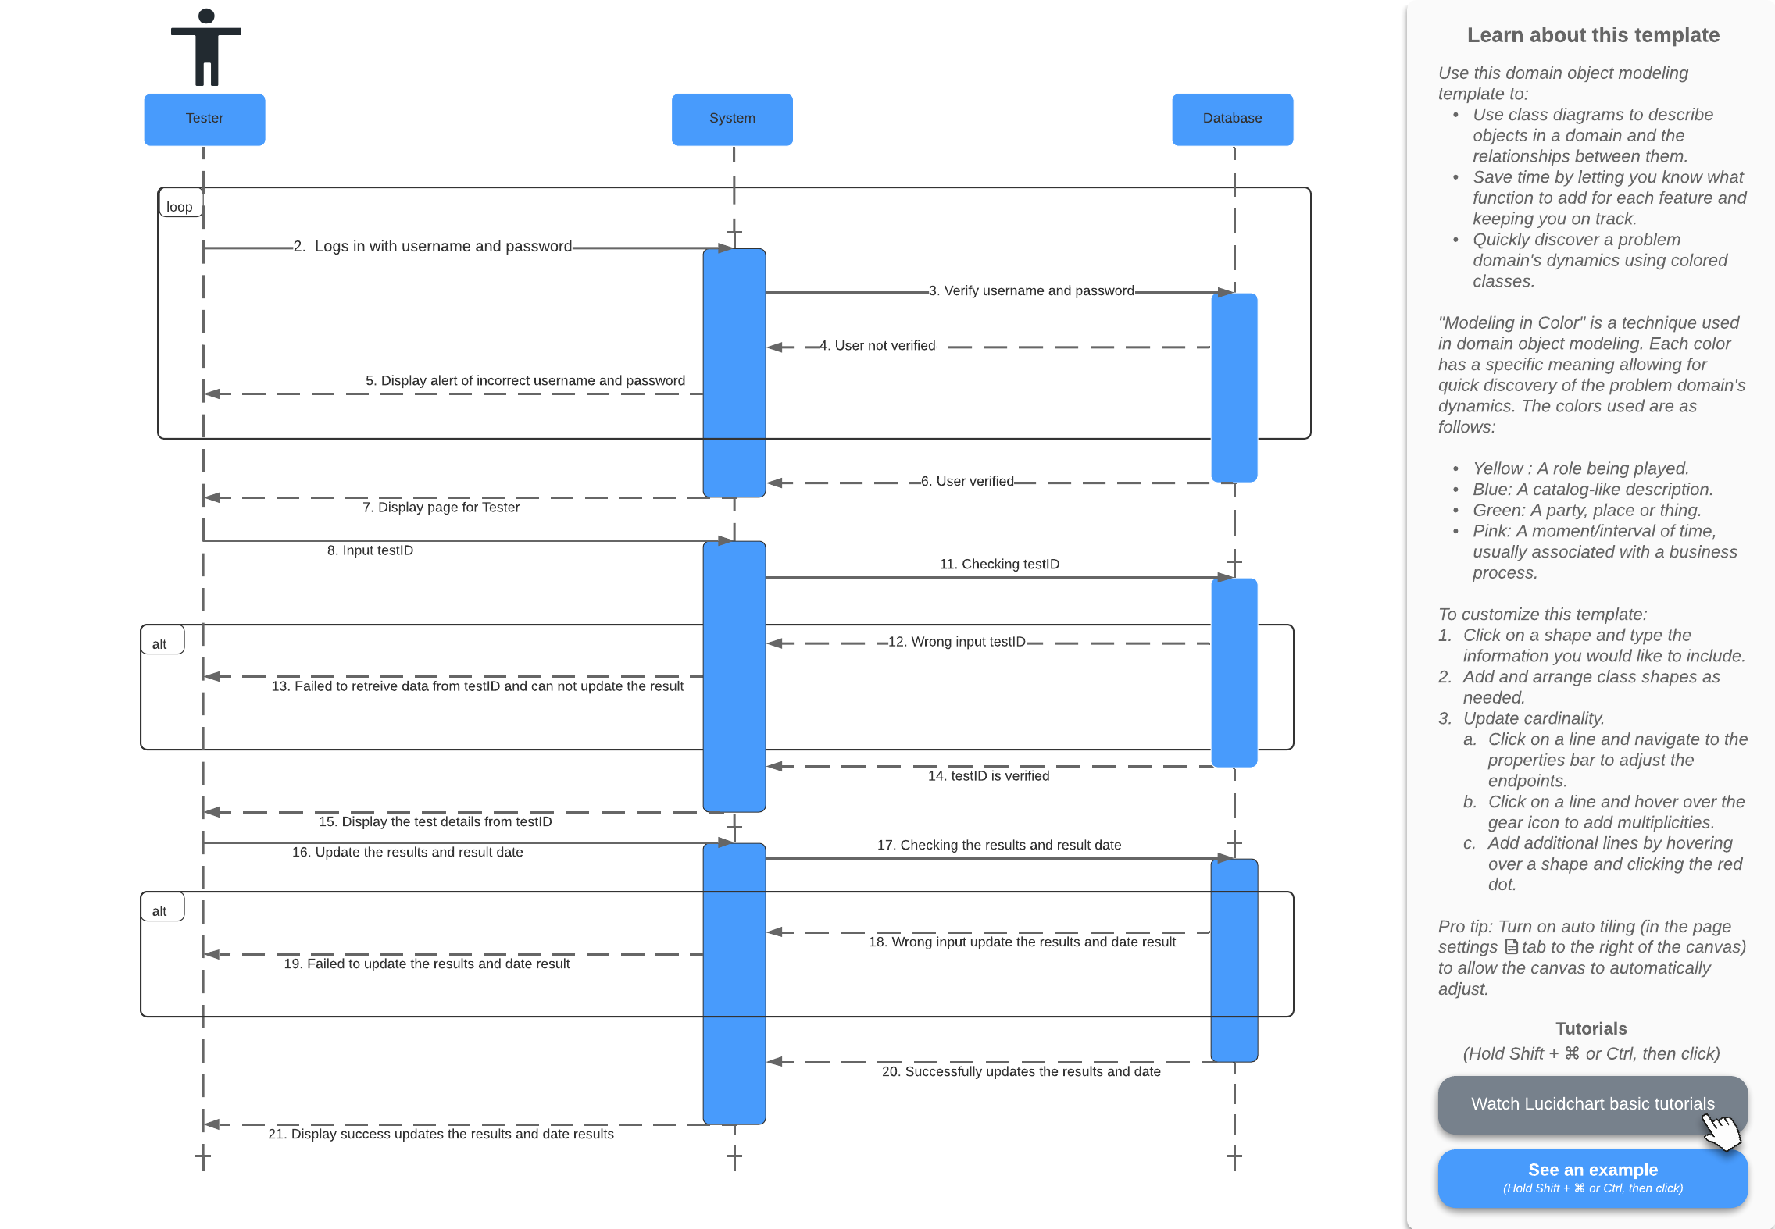

|  |  |
| --- | --- |
| **Cross References** | **Update Test Results** |
| **Operation** | Login username and password |
| **Responsible** | To get access page of tester |
| **Pre-conditions** | * The username of user must be available * The password of user must be available |
| **Post-conditions** | * Username are matched according to names in database * Password are matched based on user’s password in database |

|  |  |
| --- | --- |
| **Cross References** | **Update Test Results** |
| **Operation** | Input testID |
| **Responsible** | To get data test from testID |
| **Pre-conditions** | * The testID object must be available |
| **Post-conditions** | * Successfully display test details from testID |

|  |  |
| --- | --- |
| **Cross References** | **Update Test Results** |
| **Operation** | Input date of test and result test |
| **Responsible** | To update the result of the test |
| **Pre-conditions** | * The date of test and result object must be available |
| **Post-conditions** | * Successfully update date of test and result test |

7. View Testing History

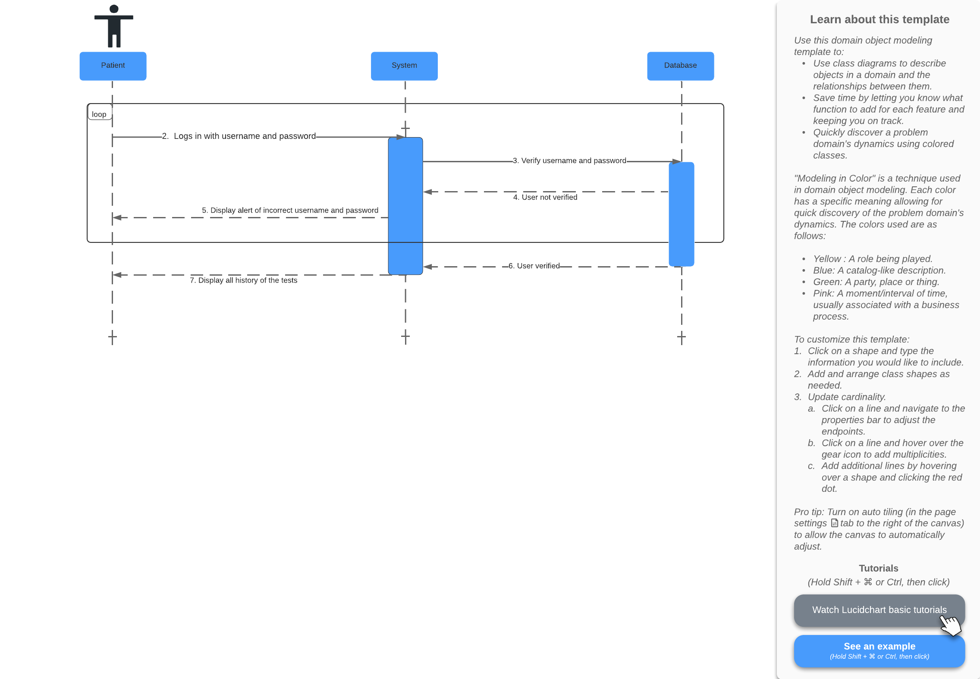

|  |  |
| --- | --- |
| **Cross References** | **View Testing History** |
| **Operation** | Login username and password |
| **Responsible** | To display all history of the tests |
| **Pre-conditions** | * The username of user must be available * The password of user must be available |
| **Post-conditions** | * Username are matched according to names in database * Password are matched based on user’s password in database * Successfully displayed all history of the tests |

8. Login

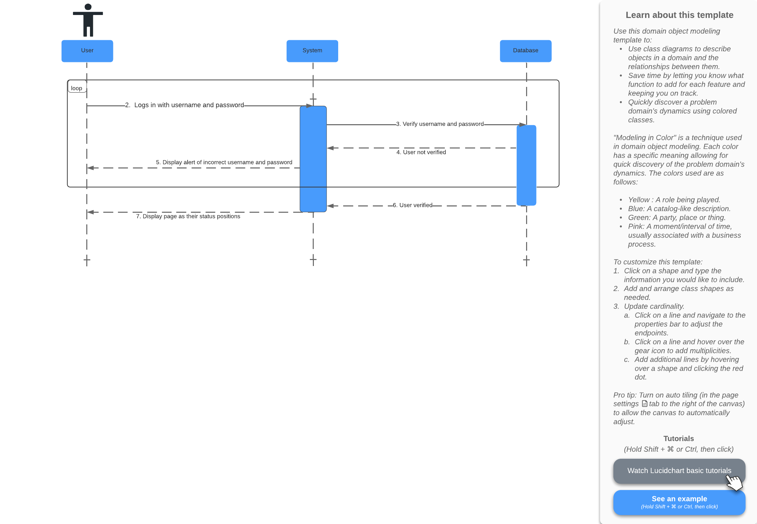

|  |  |
| --- | --- |
| **Cross References** | **Login** |
| **Operation** | Login |
| **Responsible** | To display page as their status positions |
| **Pre-conditions** | * The username of user must be available * The password of user must be available |
| **Post-conditions** | * Username are matched according to names in database * Password are matched based on user’s password in database * Successfully displayed page as their status positions |

References

Athuraliya, Amanda. 2021. What is Sequence Diagram? Complete Guide with Examples. Creately Blog. https://creately.com/blog/diagrams/sequence-diagram-tutorial/